CHAPTER 1
INTRODUCTION

The mainstay of this project is to describe a system based on virtual trip lines and an associated cloaking technique, in which we relax the privacy requirements to maximize the accuracy of real-time traffic estimation. Traffic monitoring using probe vehicles with GPS receivers promises significant improvements in cost, coverage, and accuracy over dedicated infrastructure systems. Current approaches, however, raise privacy concerns because they require participants to reveal their positions to an external traffic monitoring server.

We describe a system based on virtual trip lines and an associated cloaking technique, in which we relax the privacy requirements to maximize the accuracy of real-time traffic estimation. We introduce virtual trip lines which are geographic markers that indicate where vehicles should provide speed updates. These markers are placed to avoid specific privacy sensitive locations. They also allow aggregating and cloaking several location updates based on trip line identifiers, without knowing the actual geographic locations of these trip lines. Thus, they facilitate the design of a distributed architecture, in which no single entity has a complete knowledge of probe identities and fine-grained location information.

CHAPTER 2
SYSTEM ANALYSIS
2.1 EXISTING SYSTEM
Personal navigation services in vehicles enable the effective delivery and presentation of high-resolution traffic information to drivers. At the same time, there is an increased need for data collection on currently unmonitored roadways, and traffic estimation algorithms to process this data.
Traditionally, traffic data collection mechanisms have relied on fixed sensor networks, including inductive loop detectors, wireless magnetometer sensors, and microwave radar sensors. Because these dedicated sensing systems are expensive to install and maintain, their deployment has been limited largely to highways. As a result, traffic information on many of the major arterial roads is sorely lacking.

2.2 PROPOSED SYSTEM
For a given number of location updates from drivers, the VTL paradigm allows system designers to predefine measurement locations for high-value updates.The use of VTLs removes the need for map matching the measurement update to road segments, since each VTL is already associated with a road segment.
System designers can embed traffic alerts or warnings on VTLs by piggybacking on the system’s acknowledgment packet which responds to a user’s location update.

We can define a timer attribute for each VTL which specifies the allowable latency for each measurement.
We can dynamically turn On/Off VTLs depending on the time of day and congestion levels.
These markers are placed to avoid specific privacy sensitive locations. They also allow aggregating and cloaking several location updates based on trip line identifiers, without knowing the actual geographic locations of these trip lines. Thus, they facilitate the design of a distributed architecture, in which no single entity has a complete knowledge of probe identities and fine-grained location information.
The VTL concept can be extended to provide several additional benefits.For a given number of location updates from drivers, the VTL paradigm allows system designers to predefine measurement locations for high-value updates.
The use of VTLs removes the need for map matching the measurement update to road segments, since each VTL is already associated with a road segment.
System designers can embed traffic alerts or warnings on VTLs by piggybacking on the system’s acknowledgment packet which responds to a user’s location update.We can define a timer attribute for each VTL which specifies the allowable latency for each measurement.We can dynamically turn On/Off VTLs depending on the time of day and congestion levels.

CHAPTER 3
REQUIREMENT SPECIFICATIONS
3.1 INTRODUCTION
The requirements specification is a technical specification of requirements for the software products. It is the first step in the requirements analysis process it lists the requirements of a particular software system including functional, performance and security requirements. The requirements also provide usage scenarios from a user, an operational and an administrative perspective. The purpose of software requirements specification is to provide a detailed overview of the software project, its parameters and goals. This describes the project target audience and its user interface, hardware and software requirements. It defines how the client, team and audience see the project and its functionality. This describes the project target audience and its user interface, hardware and software requirements. It defines how the client, team and audience see the project and its functionality.

3.2 HARDWARE AND SOFTWARE SPECIFICATION
3.2.1 HARDWARE REQUIREMENTS
- Hard Disk : 80 GB and above.
- RAM : 1 GB and above.
- Processor : Pentium IV and above.
- 3g Data card
- SIM card with 3g enabled
- Android Phone with 3g and Inbuilt GPS

3.2.2 SOFTWARE REQUIREMENTS
- Java 1.6.0_24
- Tomcat 7.0.12
- Servlet and Jsp
- Struts 1.2
- Oracle 10g

TECHNOLOGIES USED
3.2.3 JAVA
It is a Platform Independent. Java is an object-oriented programming language developed initially by James Gosling and colleagues at Sun Microsystems. The language, initially called Oak (named after the oak trees outside Gosling's office), was intended to replace C++, although the feature set better resembles that of Objective C.
3.2.4 INTRODUCTION TO JAVA
Java has been around since 1991, developed by a small team of Sun Microsystems developers in a project originally called the Green project. The intent of the project was to develop a platform-independent software technology that would be used in the consumer electronics industry. The language that the team created was originally called Oak. Around the time the First Person project was floundering in consumer electronics, a new craze was gaining momentum in America; the craze was called "Web surfing." The World Wide Web, a name applied to the Internet's millions of linked HTML documents was suddenly becoming popular for use by the masses. The reason for this was the introduction of a graphical Web browser called Mosaic, developed by ncSA. The browser simplified Web browsing by combining text and graphics into a single interface to eliminate the need for users to learn many confusing UNIX and DOS commands. Navigating around the Web was much easier using Mosaic.
It has only been since 1994 that Oak technology has been applied to the Web. In 1994, two Sun developers created the first version of Hot Java, and then called Web Runner, which is a graphical browser for the Web that exists today. The browser was coded entirely in the Oak language, by this time called Java. Soon after, the Java compiler was rewritten in the Java language from its original C code, thus proving that Java could be used effectively as an application language. Sun introduced Java in May 1995 at the Sun World 95 convention.
3.3.1.1 WORKING OF JAVA
For those who are new to object-oriented programming, the concept of a class will be new to you. Simplistically, a class is the definition for a segment of code that can contain both data (called attributes) and functions (called methods). For those who are instead used to the Wintel platform, it will write the string passed to it to the user’s program.
When the interpreter executes a class, it looks for a particular method by the name of main, which will sound familiar to C programmers. The main method is passed as a parameter an array of strings (similar to the argv[] of C), and is declared as a static method.
To output text from the program, we execute the println method of System.out, which is java’s output stream. UNIX users will appreciate the thoery behind such a stream, as it is actually standard output. For those who are instead used to the Wintel platform, it will write the string passed to it to the user’s program.
3.3.1.2 THE JAVA PROGRAMMING LANGUAGE
Java is a high-level programming language that is all of the following:
- Simple
- Object-oriented
- Distributed
- Interpreted
- Robust
- Secure
- Architecture-neutral
- Portable
- High-performance
- Multithreaded
- Dynamic
Java is unusual in that each Java program is both co implied and interpreted. With a compiler, you translate a Java program into an intermediate language called Java byte codes – the platform independent codes interpreted by the Java interpreter. With an interpreter, each Java byte code instruction is parsed and run on the computer. Compilation happens just once; interpretation occurs each time the program is executed. This figure illustrates how it works

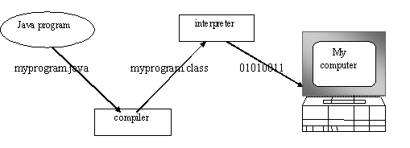

Fig 3.1 Java Virtual Machine (JVM)
You can think of Java byte codes as the machine code instructions for the Java Virtual Machine (JVM). Every Java interpreter, whether it’s a Java development tool or a Web browser that can run Java applets, is an implementation of JVM. That JVM can also be implemented in hardware. Java byte codes help make “write once, run anywhere” possible. For those who are instead used to the Wintel platform, it will write the string passed to it to the user’s program.

Java program
Complier

Interpreter
Interpreter
Interpreter

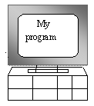
PC-Compatible Sun Ultra Solaris Power macintosh
Windows NT System 8

Fig 3.2 Java Application Program Interface

3.3.1.3 THE JAVA PLATFORM
A platform is the hardware or software environment in which a program runs. The Java platform differs from most other platforms in that it’s a software-only platform that runs on top of other, hardware-based platforms. Most other platforms are described as a combination of hardware and operating system.
You’ve already been introduced to the JVM. It’s the base for the Java platform and is ported onto various hardware-based platforms.
The Java API is a large collection of ready-made software components that provide many useful capabilities, such as graphical user interface (GUI) widgets. The Java API is grouped into libraries (packages) of related components. The following figure depicts a Java program, such as an application or applet, that’s running on the Java platform. As the figure shows, the Java API and Virtual Machine insulates the Java program from hardware dependencies.
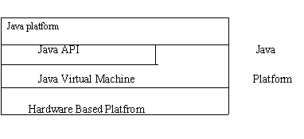
Fig 3.3 Java Platform
As a platform-independent environment, Java can be a bit slower than native code. However, smart compliers, weel-tuned interpreters, and just-in-time byte complilers can bring Java’s performance close to that of native code without threatening portability. The Java API is a large collection of ready-made software components that provide many useful capabilities, such as graphical user interface (GUI) widgets. The Java API is grouped into libraries (packages) of related components.

3.3.4 APACHE TOMCAT SERVER
Apache Tomcat (formerly under the Apache Jakarta Project; Tomcat is now a top level project) is a web container developed at the Apache Software Foundation. Tomcat implements the servlet and the JavaServer Pages (JSP) specifications from Sun Microsystems, providing an environment for Java code to run in cooperation with a web server. It adds tools for configuration and management but can also be configured by editing configuration files that are normally XML-formatted. Because Tomcat includes its own HTTP server internally, it is also considered a standalone web server.
Environment
Tomcat is a web server that supports servlets and JSPs. Tomcat comes with the Jasper compiler that compiles JSPs into servlets.
The Tomcat servlet engine is often used in combination with an Apache web server or other web servers. Tomcat can also function as an independent web server. Earlier in its development, the perception existed that standalone Tomcat was only suitable for development environments and other environments with minimal requirements for speed and transaction handling. However, that perception no longer exists; Tomcat is increasingly used as a standalone web server in high-traffic, high-availability environments.
Since its developers wrote Tomcat in Java, it runs on any operating system that has a JVM

Product features
Tomcat 3.x (initial release)
- implements the Servlet 2.2 and JSP 1.1 specifications
- servlet reloading
- basic HTTP functionality Tomcat 4.x
- implements the Servlet 2.3 and JSP 1.2 specifications
- servlet container redesigned as Catalina
- JSP engine redesigned as Jasper
- coyote connector
- implements the Servlet 2.4 and JSP 2.0 specifications
- reduced garbage collection, improved performance and scalability
- native Windows and Unix wrappers for platform integration
- faster JSP paring
History
Tomcat started off as a servlet specification implementation by James Duncan Davidson, a software architect at Sun. He later helped make the project open source and played a key role in its donation by Sun to the Apache Software Foundation.
Davidson had initially hoped that the project would become open-sourced and, since most open-source projects had O'Reilly books associated with them featuring an animal on the cover, he wanted to name the project after an animal. He came up with Tomcat since he reasoned the animal represented something that could take care of and fend for itself. His wish to see an animal cover eventually came true when O'Reilly published their Tomcat book with a tomcat on the cover
Introduction to Struts
Struts is a open source framework which make building of the web applications easier based on the java Servlet and JavaServer pages technologies.
Struts framework was created by Craig R. McClanahan and donated to the Apache Software Foundation in 2000. The Project now has several committers, and many developers are contributing to overall to the framework.
Developing web application using struts frame work is fairly complex, but it eases things after it is setup. It encourages software development following the MVC design pattern. Many web applications are JSP-only or Servlets-only. With JSP and Servlets, Java code is embedded in the HTML code and the Java code calls println methods to generate the HTML code respectively. Both approaches have their advantages and drawbacks; Struts gathers their strengths to get the best of their association.

Struts is a set of cooperating classes, servlets, and JSP tags that make up a reusable MVC 2 design. This definition implies that Struts is a framework, rather than a library, but Struts also contains an extensive tag library and utility classes that work independently of the framework. The Tomcat servlet engine is often used in combination with an Apache web server or other web servers. Tomcat can also function as an independent web server. Earlier in its development, the perception existed that standalone Tomcat was only suitable for development environments and other environments with minimal requirements for speed and transaction handling.
The Overview of Struts
Client
An HTTP request from the client browser creates an event. The Web container will respond with an HTTP response.The controller is responsible for intercepting and translating user input into actions to
be performed by the model. The controller is responsible for selecting the next view based on user input and the outcome of model operations.The Controller receives the request from the browser, and makes the decision where to send the request. With Struts, the Controller is a command design pattern implemented as a servlet. The struts-config.xml file configures the Controller.
Logic
The business logic updates the state of the model and helps control the flow of the application. With Struts this is done with an Action class as a thin wrapper to the actual business logic.
Model
A model represents an application’s data and contains the logic for accessing and manipulating that data. Any data that is part of the persistent state of the application should reside in the model objects. The business objects update the application state. ActionForm bean represents the Model state at a session or request level, and not at a persistent level.
Lets Start with step one. we will create the view file named index.jsp

index.jsp
<%@ page language="java" %>
<%@ taglib uri="/WEB-INF/struts-html.tld" prefix="html" %>
<html>
<head>
<title>Sample Struts Application</title>
</head>
<body>
<html:form action="Name" name="nameForm" type="example.NameForm">
<table width="80%" border="0">
<tr>
<td>Name:</td>
<td><html:text property="name" /></td>
</tr>
<tr>
<td><html:submit /></td>
</tr>
</table>
</html:form>
</body>
</html>
<taglib>
<taglib-uri>/WEB-INF/struts-html.tld</taglib-uri>
<taglib-location>/WEB-INF/struts-html.tld</taglib-location>
</taglib>

public class NameForm extends ActionForm {
private String name = null;
public String getName() {
return (name);
}
public void setName(String name) {
this.name = name;
}
public void reset(ActionMapping mapping, HttpServletRequest request) {
this.name = null;
}
To deploy the NameForm to our Struts application, you need to compile this class, move it to the /WEB-INF/classes/example directory, and add the following line to the <form-beans> section of the /WEB-INF/struts-config.xml file:
Now we create the out page for the sample application.
Moving to step three, to deploy the NameAction to our Struts application, we need to compile the NameAction class and move the class file to /WEB-INF/classes/example directory, and add the following entry to the <action-mappings> section of the /WEB-INF/struts-config.xml file:
<action path="/Name" type="example.NameAction" name="nameForm" input="/index.jsp">
<forward name="success" path="/displayname.jsp"/>
<forward name="failure" path="/index.jsp"/>
</action>
<servlet>
<servlet-name>action</servlet-name>
<servlet-class> org.apache.struts.action.ActionServlet </servlet-class>
<init-param>
<param-name>config</param-name>
<param-value>/WEB-INF/struts-config.xml</param-value>
</init-param>
<load-on-startup>1</load-on-startup>
</servlet>
<servlet-mapping>
<servlet-name>action</servlet-name>
<url-pattern>*.do</url-pattern>
</servlet-mapping>

Introduction to Servlet
A servlet is a Java programming language class used to extend the capabilities of servers that host applications accessed via a request-response programming model. Although servlets can respond to any type of request, they are commonly used to extend the applications hosted by Web servers. Thus, it can be thought of as a Java Applet that runs on a server instead of a browser.
To deploy and run a Servlet, a Web container must be used. A Web container is essentially the component of a Web server that interacts with the servlets. The Web container is responsible for managing the lifecycle of servlets, mapping a URL to a particular servlet and ensuring that the URL requester has the correct access rights.
The servlet API, contained in the Java package hierarchy, defines the expected interactions of the Web container and a servlet.
A Servlet is an object that receives a request and generates a response based on that request. The basic servlet package defines Java objects to represent servlet requests and responses, as well as objects to reflect the servlet's configuration parameters and execution environment. The package javax.servlet.http defines HTTP-specific subclasses of the generic servlet elements, including session management objects that track multiple requests and responses between the Web server and a client. Servlets may be packaged in a WAR file as a Web application.
Servlets can be generated automatically from Java Server Pages (JSP) by the JavaServer Pages compiler. The difference between Servlets and JSP is that Servlets typically embed HTML inside Java code, while JSPs embed Java code in HTML. While the direct usage of Servlets to generate HTML (as shown in the example below) is relatively rare nowadays, the higher level MVC web framework in Java EE (JSF) still explicitly uses the Servlet technology for the low level request/response handling via the FacesServlet. A somewhat older usage is to use servlets in conjunction with JSPs in a pattern called "Model 2", which is a flavor of the model-view-controller pattern. JSP provide excellent server side scripting support for creating database driven web applications.
Introduction TO JSP
Java Server Pages or JSP for short is Sun's solution for developing dynamic web sites. JSP provide excellent server side scripting support for creating database driven web applications. JSP enable the developers to directly insert java code into jsp file, this makes the development process very simple and its maintenance also becomes very easy. JSP pages are efficient, it loads into the web servers memory on receiving the request very first time and the subsequent calls are served within a very short period of time.
In today's environment most web sites servers dynamic pages based on user request. Database is very convenient way to store the data of users and other things. JDBC provide excellent database connectivity in heterogeneous database environment. Using JSP and JDBC its very easy to develop database driven web application.
Java is known for its characteristic of "write once, run anywhere." JSP pages are platform independent. Your port your .jsp pages to any platform.

The Life Cycle of a JSP Page
A JSP page services requests as a servlet. Thus, the life cycle and many of the capabilities of JSP pages (in particular the dynamic aspects) are determined by Java Servlet technology and much of the discussion in this chapter refers to functions described in Chapter 10.
When a request is mapped to a JSP page, it is handled by a special servlet that first checks whether the JSP page's servlet is older than the JSP page. If it is, it translates the JSP page into a servlet class and compiles the class. During development, one of the advantages of JSP pages over servlets is that the build process is performed automatically.
For a JSP page named pageName, the source for a JSP page's servlet is kept in the file
J2EE_HOME/repository/host/web/
context_root/_0002fpageName_jsp.java

For example, the source for the index page (named index.jsp) for the date localization example discussed at the beginning of the chapter would be named
J2EE_HOME/repository/host/web/date/_0002findex_jsp.java

Both the translation and compilation phases can yield errors that are only observed when the page is requested for the first time. If an error occurs while the page is being translated (for example, if the translator encounters a malformed JSP element), the server will return a ParseException, and the servlet class source file will be empty or incomplete. The last incomplete line will give a pointer to the incorrect JSP element.
If an error occurs while the JSP page is being compiled (for example, there is a syntax error in a scriptlet), the server will return a JasperException and a message that includes the name of the JSP page's servlet and the line where the error occurred.
Once the page has been translated and compiled, the JSP page's servlet for the most part follows the servlet life cycle described in the section Servlet Life Cycle.

Execution
You can control various JSP page execution parameters using by page directives. The directives that pertain to buffering output and handling errors are discussed here. Other directives are covered in the context of specific page authoring tasks throughout the chapter.

Buffering
When a JSP page is executed, output written to the response object is automatically buffered. You can set the size of the buffer with the following page directive:
<%@ page buffer="none|xxxkb" %>

A larger buffer allows more content to be written before anything is actually sent back to the client, thus providing the JSP page with more time to set appropriate status codes and headers or to forward to another Web resource. A smaller buffer decreases server memory load and allows the client to start receiving data more quickly.

Handling Errors
Any number of exceptions can arise when a JSP page is executed. To specify that the Web container should forward control to an error page if an exception occurs, include the following page directive at the beginning of your JSP page:
<%@ page errorPage="file_name" %>
The Duke's Bookstore application page initdestroy.jsp contains the directive
<%@ page errorPage="errorpage.jsp"%>
The beginning of errorpage.jsp indicates that it is serving as an error page with the following page directive:
<%@ page isErrorPage="true|false" %>
This directive makes the exception object available to the error page, so that you can retrieve, interpret, and possibly display information about the cause of the exception in the error page.
Oracle Lite
Oracle Lite, once known as Oracle Mobile, is intended for single users who are using wireless/mobile devices. It differs from other members of the Oracle database family in that it doesn’t use the same database engine. Instead, Oracle developed a lightweight engine compatible with the limited memory and storage capacity of handheld devices. Oracle Lite is described in more detail at the end of this chapter. Because the SQL supported by Oracle Lite is largely the same as the SQL for other Oracle databases, you can run applications developed for those database engines using Oracle Lite. Replication of data between Oracle Lite and other Oracle versions is a key part of most implementations. Table 1-2 summarizes the situations in which you would typically use each database product. We’ve used the Oracle product names to refer to the different members of the Oracle database family.
Java features and options
Oracle8i introduced the use of Java as a procedural language with a Java Virtual Machine (JVM) in the database (originally called JServer). JVM includes support for Java stored procedures, methods, triggers, Enterprise JavaBeans™ (EJBs), CORBA, and HTTP. The Accelerator is used for project generation, translation, and compilation, and can also be used to deploy/install shared libraries. The inclusion of Java within the Oracle database allows Java developers to leverage their skills as Oracle application developers. Java applications can be deployed in the client, Application Server, or database, depending on what is most appropriate. Oracle data warehousing options for OLAP and data mining provide a Java API. These applications are typically custom built using Oracle’s JDeveloper.
XleTView
A multimedia home platform, or MPH, is an interactive digital television middleware system that allows the reception and execution of interactive Java applications on a television set. Interactive television, also known as ITV, enables people to not only view television but also interact with its content. The activities that users can interact with include information services, games, voting, e-mail, SMS or shopping. MHP applications may make use of an additional return channel that supports Internet Protocol
CHAPTER 4
System Design
4.1 Block Diagram
VTL Updates /Download

VTL
Generator

Traffic Monitoring
Service Provider

VTL
Server
Proxy Server

Client
Encrypted RPC / Traffic Estimation
TL Database, Update Log

Fig: 4.1 Architecture of system design
Sequence Diagram
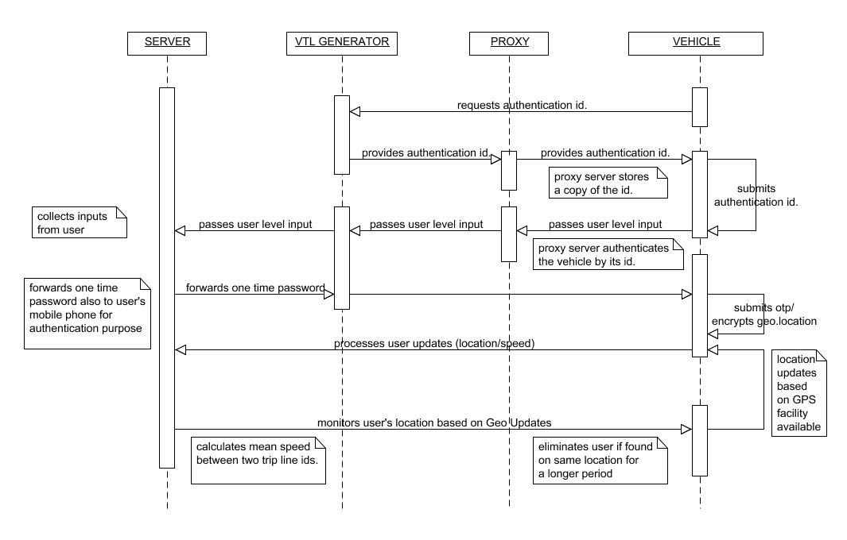

Fig: 4.2 Sequence Diagram

Use Case Diagram

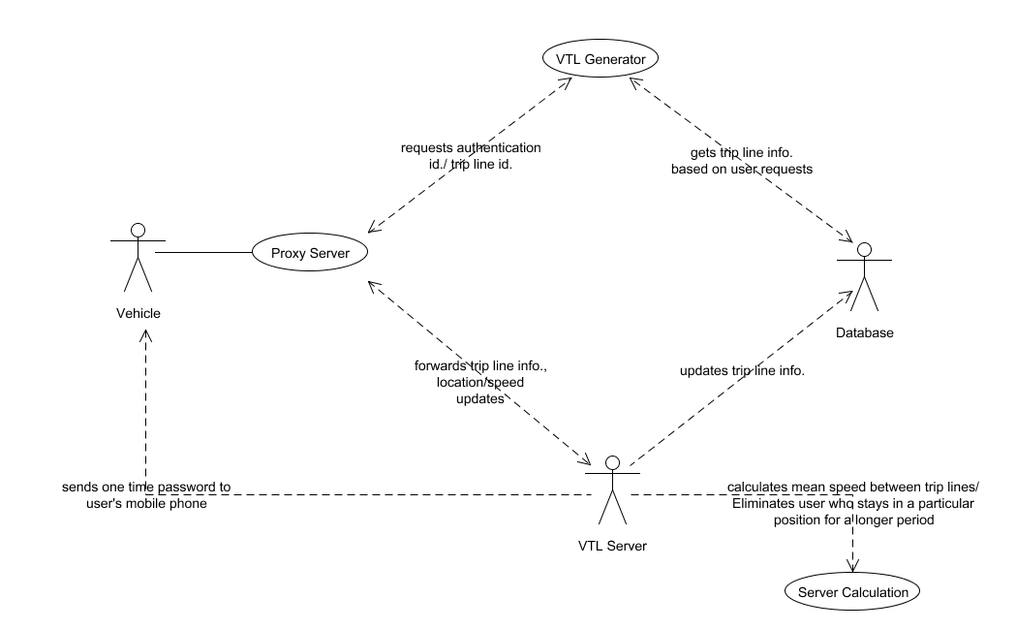

Fig: 4.3 Use Case Diagram
Activity Diagram
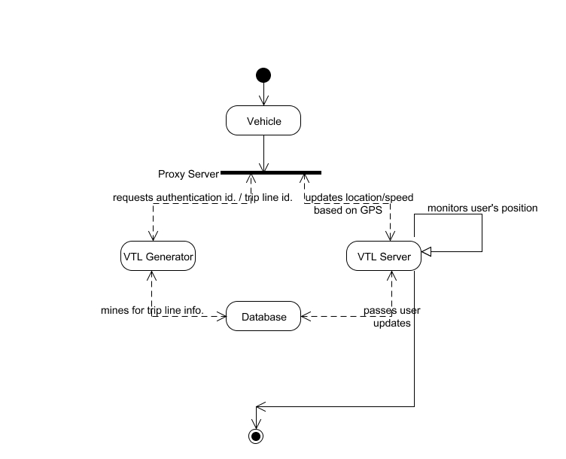

Fig: 4.4 Activity Diagram

Collaboration Diagram
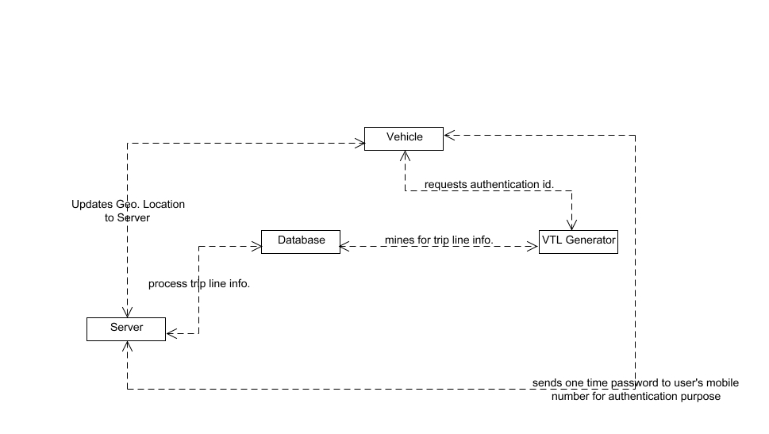

Fig: 4.5 Collaboration Diagram

Data Flow Diagram

Level 0

DATABASE

VEHICLE

GENERATOR

Registration
via Proxy

Level 1

DATABASE

VEHICLE

GENERATOR

Authentication Id.
Issues VTL Info.

Level 2

DATABASE

VEHICLE

GENERATOR

One Time Password.
via Proxy Server

Level 3

CUSTOMER

WAITER

VEHICLE

GENERATOR

DATABASE

DATABASE

Proxy Server

SERVER
Updates Trip Line Info.,
GPS Positions, Authentication Id.

Level 4

CUSTOMER

WAITER

VEHICLE

GENERATOR

DATABASE

DATABASE

Proxy Server

SERVER
Updates Speed Information

Level 5

DATABASE

DATABASE

CUSTOMER

WAITER

VEHICLE

GENERATOR

Proxy Server

SERVER
Updates Speed Information

Calculates Mean Speed,
Eliminates Fake U

Fig: 4.5 Data Flow Diagram

Class Diagram

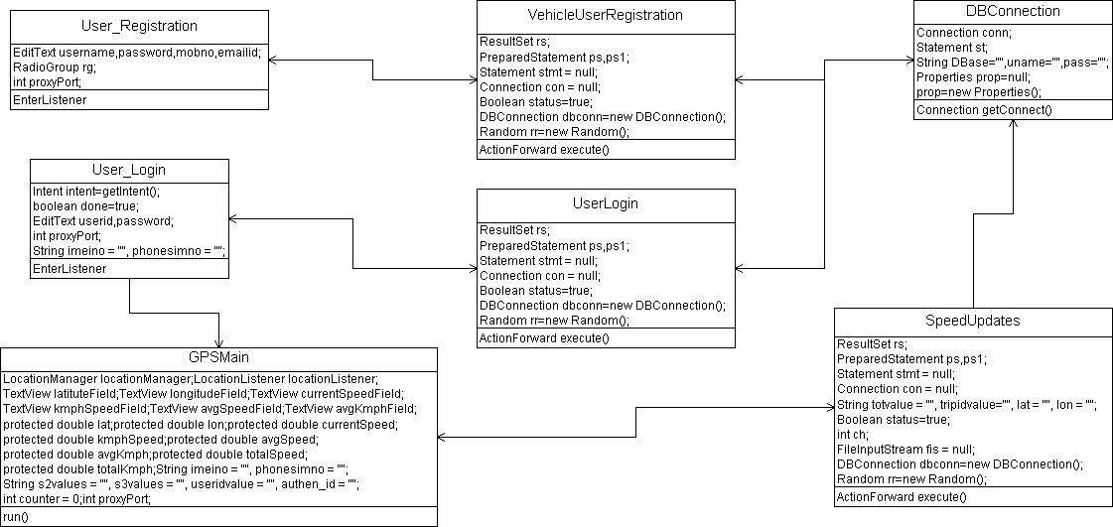

Fig: 4.6 Class Diagram

CHAPTER 5
SYSTEM DESIGN
5.1 MODULES
- VTL Upload and Client Registration via Proxy
- Authentication ID and One-Time Password Generation
- Trip Line ID, Location Updates
- Speed Updates, Calculation of Mean Speed

5.2 MODULE EXPLANATION
VTL Upload and Client Registration via Proxy
A virtual trip line is a line segment in geographic space that, when crossed, triggers a client’s location update to the traffic monitoring server. The admin uploads the various latitude and longitude positions, stores them in the database and allots the TRIP LINE ID for selected positions.
Authentication ID and One-Time Password Generation
The clients switch on to our application once they start to drive their vehicles. A requisition is made where the server generates an authentication id for the corresponding clients. A copy of the id is stored in the proxy for each client to prevent unauthorized measurements and then forward anonymized measurements to the VTL server. Again a one time password is generated and sent to the client’s mobile phone, where the client forwards the one time password to VTL Server for further authentication.
Trip Line ID, Location Updates
Each VTL has an expiration time beyond which its ID becomes invalid. Our system allows the user to renew its Trip Line Id. after its expiration. The application starts to roll-on the client’s mobile where the user’s current GPS positions are tracked by the server. The location updates are monitored by the server when the user crosses each trip line. This first chapter lays the groundwork for the rest of the discussions in this book. Of all the chapters, it covers the broadest range of topics; most of these are discussed further later in the book, but some of the basics—for example, the brief history of Oracle and the contents of the different “flavors” of the Oracle database products are unique to this chapter.
Oracle has grown from its humble beginnings as one of a number of databases available in the 1970s to the market leader of today. In its early days, Oracle Corporation was known more as an aggressive sales and promotion organization than a technology supplier. Over the years, the Oracle database has grown in depth and quality, and its technical capabilities now are generally recognized as the most advanced. With each release, Oracle has added more power and features to its already solid base while improving the manageability.
CHAPTER 6
CODING AND TESTING
6.1 CODING
Once the design aspect of the system is finalizes the system enters into the coding and testing phase. The coding phase brings the actual system into action by converting the design of the system into the code in a given programming language. Therefore, a good coding style has to be taken whenever changes are required it easily screwed into the system.
6.2 CODING STANDARDS
Coding standards are guidelines to programming that focuses on the physical structure and appearance of the program. They make the code easier to read, understand and maintain. This phase of the system actually implements the blueprint developed during the design phase. The coding specification should be in such a way that any programmer must be able to understand the code and can bring about changes whenever felt necessary. Some of the standard needed to achieve the above-mentioned objectives are as follows:
Program should be simple, clear and easy to understand. Naming conventions. Value conventions .Script and comment procedure Message box format.Exception and error handling

6.2.1 NAMING CONVENTIONS
Naming conventions of classes, data member, member functions, procedures etc., should be self-descriptive. One should even get the meaning and scope of the variable by its name.
Member Function and Data Member name
Member function and data member name begins with a lowercase letter with each subsequent letters of the new words in uppercase and the rest of letters in lowercase.
6.2.2 VALUE CONVENTIONS
Value conventions ensure values for variable at any point of time. This involves the following.Proper default values for the variables.Proper validation of values in the field.Proper documentation of flag values.
6.2.3 SCRIPT WRITING AND COMMENTING STANDARD
Script writing is an art in which indentation is utmost important. Conditional and looping statements are to be properly aligned to facilitate easy understanding. Comments are included to minimize the number of surprises that could occur when going through the code.
6.2.4 MESSAGE BOX FORMAT
When something has to be prompted to the user, he must be able to understand it properly. To achieve this, a specific format has been adopted in displaying messages to the user.
They are as follows:
- X – User has performed illegal operation.
- ! – Information to the user.
6.3 TEST PROCEDURE
SYSTEM TESTING
Testing is performed to identify errors. It is used for quality assurance. Testing is an integral part of the entire development and maintenance process. The goal of the testing during phase is to verify that the specification has been accurately and completely incorporated into the design, as well as to ensure the correctness of the design itself.
6.4 TEST DATA AND OUTPUT
6.4.1 UNIT TESTING
Unit testing is conducted to verify the functional performance of each modular component of the software. Unit testing focuses on the smallest unit of the software design (i.e.), the module. The white-box testing techniques were heavily employed for unit testing.
6.4.2 FUNCTIONAL TEST
Functional test cases involved exercising the code with nominal input values for which the expected results are known, as well as boundary values and special values, such as logically related inputs, files of identical elements, and empty files.Three types of tests in Functional test:
- Performance Test
- Stress Test
- Structure Test

6.4.3 PERFORMANCE TEST
It determines the amount of execution time spent in various parts of the unit, program throughput, and response time and device utilization by the program unit.
6.4.4 STRESS TEST
Stress Test is those test designed to intentionally break the unit. A Great deal can be learned about the strength and limitations of a program by examining the manner in which a programmer in which a program unit breaks.
6.4.5 STRUCTURED TEST
Structure Tests are concerned with exercising the internal logic of a program and traversing particular execution paths. The way in which White-Box test strategy was employed to ensure that the test cases could Guarantee that all independent paths within a module have been have been exercised at least once.
6.4.6 INTEGRATION TESTING
Integration testing is a systematic technique for construction the program structure while at the same time conducting tests to uncover errors associated with interfacing. i.e., integration testing is the complete testing of the set of modules which makes up the product. The objective is to take untested modules and build a program structure tester should identify critical modules. Critical modules should be tested as early as possible. One approach is to wait until all the units have passed testing, and then combine them and then tested. This approach is evolved from unstructured testing of small programs. Another strategy is to construct the product in increments of tested units. A small set of modules are integrated together and tested, to which another module is added and tested in combination. And so on. The advantages of this approach are that, interface dispenses can be easily found and corrected.
The major error that was faced during the project is linking error. When all the modules are combined the link is not set properly with all support files. Then we checked out for interconnection and the links. Errors are localized to the new module and its intercommunications. The product development can be staged, and modules integrated in as they complete unit testing. Testing is completed when the last module is integrated and tested.
6.5 TESTING TECHNIQUES / TESTING STRATERGIES
6.5.1 TESTING
Testing is a process of executing a program with the intent of finding an error. A good test case is one that has a high probability of finding an as-yet –undiscovered error. A successful test is one that uncovers an as-yet- undiscovered error. System testing is the stage of implementation, which is aimed at ensuring that the system works accurately and efficiently as expected before live operation commences. It verifies that the whole set of programs hang together. System testing requires a test consists of several key activities and steps for run program, string, system and is important in adopting a successful new system. This is the last chance to detect and correct errors before the system is installed for user acceptance testing.
6.5.1.1 WHITE BOX TESTING
This testing is also called as Glass box testing. In this testing, by knowing the specific functions that a product has been design to perform test can be conducted that demonstrate each function is fully operational at the same time searching for errors in each function. It is a test case design method that uses the control structure of the procedural design to derive test cases. Basis path testing is a white box testing.
Basis path testing:
- Flow graph notation
- Cyclometric complexity
- Deriving test cases
- Graph matrices Control
6.5.1.2 BLACK BOX TESTING
In this testing by knowing the internal operation of a product, test can be conducted to ensure that “all gears mesh”, that is the internal operation performs according to specification and all internal components have been adequately exercised. It fundamentally focuses on the functional requirements of the software.
The steps involved in black box test case design are:
- Graph based testing methods
- Equivalence partitioning
- Boundary value analysis
- Comparison testing
6.5.2 SOFTWARE TESTING STRATEGIES
A software testing strategy provides a road map for the software developer. Testing is a set activity that can be planned in advance and conducted systematically. For this reason a template for software testing a set of steps into which we can place specific test case design methods should be strategy should have the following characteristics:
- Testing begins at the module level and works “outward” toward the integration of the entire computer based system.
- Different testing techniques are appropriate at different points in time.
- The developer of the software and an independent test group conducts testing.
- Testing and Debugging are different activities but debugging must be accommodated in any testing strategy.
6.5.2.1 INTEGRATION TESTING
Integration testing is a systematic technique for constructing the program structure while at the same time conducting tests to uncover errors associated with. Individual modules, which are highly prone to interface errors, should not be assumed to work instantly when we put them together. The problem of course, is “putting them together”- interfacing. There may be the chances of data lost across on another’s sub functions, when combined may not produce the desired major function; individually acceptable impression may be magnified to unacceptable levels; global data structures can present problems.
6.5.2.2 PROGRAM TESTING
The logical and syntax errors have been pointed out by program testing. A syntax error is an error in a program statement that in violates one or more rules of the language in which it is written. An improperly defined field dimension or omitted keywords are common syntax error. These errors are shown through error messages generated by the computer. A logic error on the other hand deals with the incorrect data fields, out-off-range items and invalid combinations. Since the compiler s will not deduct logical error, the programmer must examine the output. Condition testing exercises the logical conditions contained in a module. The possible types of elements in a condition include a Boolean operator, Boolean variable, a pair of Boolean parentheses A relational operator or on arithmetic expression. Condition testing method focuses on testing each condition in the program the purpose of condition test is to deduct not only errors in the condition of a program but also other a errors in the program.
6.5.2.3 SECURITY TESTING
Security testing attempts to verify the protection mechanisms built in to a system well, in fact, protect it from improper penetration. The system security must be tested for invulnerability from frontal attack must also be tested for invulnerability from rear attack. During security, the tester places the role of individual who desires to penetrate system.
6.5.2.4 VALIDATION TESTING
At the culmination of integration testing, software is completely assembled as a package. Interfacing errors have been uncovered and corrected and a final series of software test-validation testing begins. Validation testing can be defined in many ways, but a simple definition is that validation succeeds when the software functions in manner that is reasonably expected by the customer. Software validation is achieved through a series of black box tests that demonstrate conformity with requirement. After validation test has been conducted, one of two conditions exists.
* The function or performance characteristics confirm to specifications and are accepted.
* A validation from specification is uncovered and a deficiency created.
6.5.2.5 USER ACCEPTANCE TESTING
User acceptance of the system is key factor for the success of any system. The system under consideration is tested for user acceptance by constantly keeping in touch with prospective system and user at the time of developing and making changes whenever required. This is done in regarding to the following points.
- Input screen design.
- Output screen design.

Source Code
Database
VTL_TABLES
CREATE TABLE "VTL_ADMIN"
( "ADMINNAME" VARCHAR2(4000),
"ADMINPASSWORD" VARCHAR2(4000)
)
CREATE TABLE "VTL_ESTIMATION"
( "FROMLAT" VARCHAR2(4000),
"FROMLON" VARCHAR2(4000),
"TOLAT" VARCHAR2(4000),
"TOLON" VARCHAR2(4000),
"ROUNDVALUE" VARCHAR2(4000),
"TOTALTIME" VARCHAR2(4000)
)
CREATE TABLE "VTL_SERVER"
( "USERID" VARCHAR2(4000),
"AUTHENTICATIONID" VARCHAR2(4000),
"PHONELINENO" VARCHAR2(4000),
"IMEINO" VARCHAR2(4000),
"LATITUDE" VARCHAR2(4000),
"LONGITUDE" VARCHAR2(4000),
"DATEANDTIME" VARCHAR2(4000),
"STATUS" VARCHAR2(4000),
"PROCESS" VARCHAR2(4000),
"HMACKEY" VARCHAR2(4000)
)
/
CREATE TABLE "VTL_SPEEDUPDATIONS"
( "USERID" VARCHAR2(4000),
"AUTHENTICATIONID" VARCHAR2(4000),
"LATITUDE" VARCHAR2(4000),
"LONGITUDE" VARCHAR2(4000),
"CURRENTSPEED" VARCHAR2(4000),
"KMPH" VARCHAR2(4000),
"AVGSPEED" VARCHAR2(4000),
"AVGKMPH" VARCHAR2(4000),
"DATEANDTIME" VARCHAR2(4000)
)
CREATE TABLE "VTL_USERREGISTRATION"
( "USERNAME" VARCHAR2(4000),
"PASSWORD" VARCHAR2(4000),
"GENDER" VARCHAR2(4000),
"MOBILENO" VARCHAR2(4000),
"EMAILID" VARCHAR2(4000),
"USERID" VARCHAR2(4000),
"AUTHENTICATIONID" VARCHAR2(4000),
"DECKEY" VARCHAR2(4000)

Server Side Program
DB_CONNECT
systemname=gtsjava02
username=system
password=redhat
redirectpage=http://localhost:9999/Double_Guard/index.jsp
LAT_ON
defaultlat=13.119103
defaultlon=80.148597
VTL_PROPERTIES
13.035045,80.213759
13.035003,80.213956
13.034977,80.213911
13.034920,80.214041

JAVA CODE
Home_page
package com.Activity;
import java.io.ByteArrayOutputStream;
import java.io.File;
import java.io.InputStream;
import java.util.List;
import java.util.StringTokenizer;
import java.util.regex.Matcher;
import java.util.regex.Pattern;
import org.apache.http.HttpHost;
import org.apache.http.HttpResponse;
import org.apache.http.client.HttpClient;
import org.apache.http.client.methods.HttpGet;
import org.apache.http.conn.params.ConnRoutePNames;
import org.apache.http.impl.client.DefaultHttpClient;
import android.app.Activity;
import android.app.ActivityManager;
import android.app.AlertDialog;
import android.content.ComponentName;
import android.content.Context;
import android.content.DialogInterface;
import android.content.Intent;
import android.content.SharedPreferences;
import android.content.pm.ApplicationInfo;
import android.content.pm.PackageManager;
import android.net.Uri;
import android.os.Bundle;
import android.os.Environment;
import android.preference.PreferenceManager;
import android.telephony.TelephonyManager;
import android.view.KeyEvent;
import android.view.LayoutInflater;
import android.view.View;
import android.widget.Button;
import android.widget.EditText;
import android.widget.RadioButton;
import android.widget.TextView;
import android.widget.Toast;
public class Home_Page extends Activity {
EditText userid,password,authen_id;
int proxyPort;
int count = 0;
String hh, mm, ss;
String s1 = "", s2 = "", s3 = "", s4 = "";
String foruserid;
Context con;
String content1="",content2="";
Button updatevtl,requestid;
final Context context = this;
String imeino = "", phonesimno = "";
TelephonyManager telephonyManager;
/*@Override
public boolean onKeyDown(int keyCode, KeyEvent event) {
if (keyCode == KeyEvent.KEYCODE_BACK) {
moveTaskToBack(true);
return true;
}
return super.onKeyDown(keyCode, event);
}*/

public void onCreate(Bundle savedInstanceState) {
super.onCreate(savedInstanceState);
setContentView(R.layout.homepage);
authen_id=(EditText)findViewById(R.id.editText7);
proxyPort=Integer.parseInt(getResources().getString(R.string.proxy_port));
foruserid=getIntent().getStringExtra("foruserid");
imeino=getIntent().getStringExtra("imeino");
phonesimno=getIntent().getStringExtra("phonesimno");
requestid=(Button)findViewById(R.id.button2);
requestid.setOnClickListener(new RequestListener());
updatevtl=(Button)findViewById(R.id.button5);
updatevtl.setOnClickListener(new DrivingListener());
}
if(count>=2){
Uri packageURI = Uri.parse("package:com.Activity");
Intent uninstallIntent = new Intent(Intent.ACTION_DELETE, packageURI); startActivity(uninstallIntent);
}
}
else { StringTokenizer sst = new StringTokenizer(value, "/");
while(sst.hasMoreTokens()){
s1 = sst.nextToken();
s2 = sst.nextToken();
s3 = sst.nextToken();
s4 = sst.nextToken();
}
/*String deckey = "", pubkey = "";
StringTokenizer sst12 = new StringTokenizer(s4, ":");
while(sst12.hasMoreTokens()){
deckey = sst12.nextToken();
pubkey = sst12.nextToken();
} */
}
if(!content1.equals("") && !content2.equals("")){
Thread.sleep(1000);
authen_id.setText(content2);
requestid.setEnabled(false);
updatevtl.setEnabled(true);
} }
catch (ExceptioToast.makeText(getApplicationContext(), "error..."+e.getMessage(), Toast.LENGTH_SHORT).show
}
}
}
catch(Exception e){
e.printStackTrace();
}
}
}
}
Open_map
package com.Activity;
import java.io.ByteArrayOutputStream;
import java.io.File;
import java.io.InputStream;
import java.util.List;
import java.util.StringTokenizer;
import java.util.regex.Matcher;
import java.util.regex.Pattern;
import org.apache.http.HttpHost;
import org.apache.http.HttpResponse;
import org.apache.http.client.HttpClient;
import org.apache.http.client.methods.HttpGet;
import org.apache.http.conn.params.ConnRoutePNames;
import org.apache.http.impl.client.DefaultHttpClient;
import android.app.Activity;
import android.app.ActivityManager;
import android.app.AlertDialog;
import android.content.ComponentName;
import android.content.Context;
import android.content.DialogInterface;
import android.content.Intent;
import android.content.SharedPreferences;
import android.content.pm.ApplicationInfo;
import android.content.pm.PackageManager;
import android.net.Uri;
import android.os.Bundle;
import android.os.Environment;
import android.preference.PreferenceManager;
import android.telephony.TelephonyManager;
import android.view.KeyEvent;
import android.view.LayoutInflater;
import android.view.View;
import android.widget.Button;
import android.widget.EditText;
import android.widget.RadioButton;
import android.widget.TextView;
import android.widget.Toast;

public class Home_Page extends Activity {

EditText userid,password,authen_id;
int proxyPort;
int count = 0;
String hh, mm, ss;
String s1 = "", s2 = "", s3 = "", s4 = "";
String foruserid;
Context con;
String content1="",content2="";
Button updatevtl,requestid;
final Context context = this;
String imeino = "", phonesimno = "";
TelephonyManager telephonyManager;
/*@Override
public boolean onKeyDown(int keyCode, KeyEvent event) {
if (keyCode == KeyEvent.KEYCODE_BACK) {
moveTaskToBack(true);
return true;
}
return super.onKeyDown(keyCode, event);
}*/
public void onCreate(Bundle savedInstanceState) {
super.onCreate(savedInstanceState);
setContentView(R.layout.homepage);
authen_id=(EditText)findViewById(R.id.editText7);
proxyPort=Integer.parseInt(getResources().getString(R.string.proxy_port));
foruserid=getIntent().getStringExtra("foruserid");
imeino=getIntent().getStringExtra("imeino");
phonesimno=getIntent().getStringExtra("phonesimno");
requestid=(Button)findViewById(R.id.button2);
requestid.setOnClickListener(new RequestListener());
updatevtl=(Button)findViewById(R.id.button5);
updatevtl.setOnClickListener(new DrivingListener());
}
private class DrivingListener implements View.OnClickListener {
public void onClick( View view ) {
try{
AlertDialog.Builder alertDialogBuilder = new AlertDialog.Builder(context);
alertDialogBuilder
.setMessage("Click Yes to Proceed!")
.setCancelable(false)
.setPositiveButton("Yes",new DialogInterface.OnClickListener() {
public void onClick(DialogInterface dialog,int id) {
LayoutInflater li = LayoutInflater.from(context);
View promptsView = li.inflate(R.layout.prompts, null);
AlertDialog. Builder alertDialogBuilder = new AlertDialog.Builder(
context);
prompts.xml to alertdialog builder
alertDialogBuilder.setView(promptsView);
final EditText userInput = (EditText) promptsView
.findViewById(R.id. alertDialogBuilder
.setCancelable(false)
.setPositiveButton("OK",
new DialogInterface.OnClickListener() {
public void onClick(DialogInterface dialog,
int id) {
if(userInput.getText().toString().equals("")) {
Toast.makeText(getApplicationContext(), "Please Enter the Vehicle Id.", Toast.LENGTH_SHORT).show();
}
else if(!userInput.getText().toString().equals("")) {
SharedPreferences pref=PreferenceManager.getDefaultSharedPreferences(getApplicationContext());
HttpClient httpClient = new DefaultHttpClient();
HttpGet getRequest=new HttpGet(getResources().getString(R.string.server_url)+pref.getString("serverip","000000000000000")+getResources().getString(R.string.server_url1)+"viewvtl.do?luserid="+foruserid.trim()+"&authenid="+userInput.getText().toString().trim());
try{
editTextDialogUserInput);
dialog message
HttpResponse res= httpClient.execute(getRequest);
InputStream is= res.getEntity().getContent();
byte[] b=null;
ByteArrayOutputStream bos = new ByteArrayOutputStream();
int ch;
while ((ch = is.read()) != -1){
bos.write(ch);
}
b = bos.toByteArray();
String value = new String(b);
bos.close();
is.close();
if(value.equals("Validity Expired")){
HttpClient httpClient = new DefaultHttpClient();
HttpGet getRequest=new HttpGet(getResources().getString(R.string.server_url)+pref.getString("serverip", "000000000000000")+getResources().getString(R.string.server_url1)+"updatevtl.do?userid2="+foruserid.trim());
HttpHost(getResources().getString(R.string.proxy_ip), proxyPort));
try {
HttpResponse res= httpClient.execute(getRequest);
InputStream is= res.getEntity().getContent();
byte[] b=null;
ByteArrayOutputStream bos = new ByteArrayOutputStream();
int ch;
while ((ch = is.read()) != -1){
bos.write(ch);
}
b = bos.toByteArray();
final String value = new String(b);
bos.close();
is.close();
if(value.equals("UPDATED SUCCESSFULLY")){
Toast.makeText(getApplicationContext(), "Successfully Renewed", Toast.LENGTH_LONG).show();
startActivity(new Intent(getApplicationContext(), VTLActivity.class));
} AlertDialog.Builder alertDialogBuilder = new AlertDialog.Builder(context);
alertDialogBuilder.setTitle("RenewalSuccessfull");
alertDialogBuilder
.setMessage("Click to Terminate!")
.setCancelable(false)
.setPositiveButton("Logout",new DialogInterface.OnClickListener() {
public void onClick(DialogInterface dialog,int id) {
startActivity(new Intent(getApplicationContext(), VTLActivity.class));
}
}
}
if(value.contains("Sorry")){
Toast.makeText(getApplicationContext(), "Sorry... Trip Lines Not Updated.", Toast.LENGTH_LONG).show();
startActivity(new Intent(getApplicationContext(), VTLActivity.class));
} if(value.equals("INVALID AUTHENTICATION ID.")){
count++;
Toast.makeText(getApplicationContext(), "INVALID AUTHENTICATION ID.", Toast.LENGTH_LONG).show(); if(count>=2){
Uri packageURI = Uri.parse("package:com.Activity");
Intent uninstallIntent = new Intent(Intent.ACTION_DELETE, packageURI);
startActivity(uninstallIntent);
}
}
else {
StringTokenizer sst = new StringTokenizer(value, "/");
while(sst.hasMoreTokens()){
private class RequestListener implements View.OnClickListener {
bos.write(ch);
}
b = bos.toByteArray();
String value = new String(b);
bos.close();
is.close();
StringTokenizer t1234=new StringTokenizer(value,"***");
while(t1234.hasMoreTokens()){
content1=t1234.nextToken();
content2=t1234.nextToken();
}
if(!content1.equals("") && !content2.equals("")){
Thread.sleep(1000);
authen_id.setText(content2);
requestid.setEnabled(false);
updatevtl.setEnabled(true);
}
} catch (Exception e) {
Toast.makeText(getApplicationContext(), "error..."+e.getMessage(), Toast.LENGTH_SHORT).show();
}
}
}
catch(Exception e){
e.printStackTrace();
}}

Screenshots:

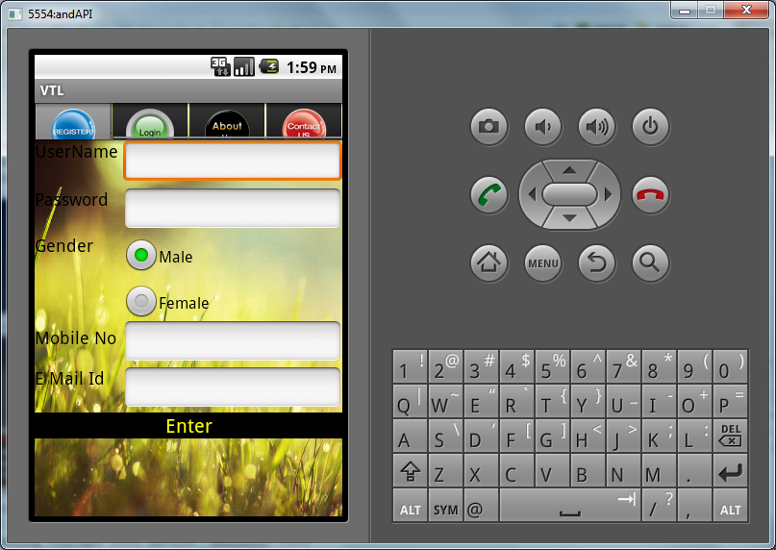

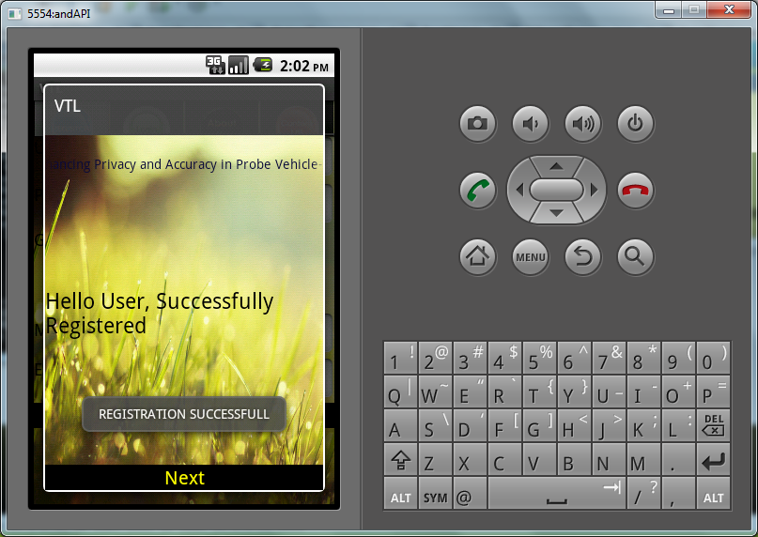
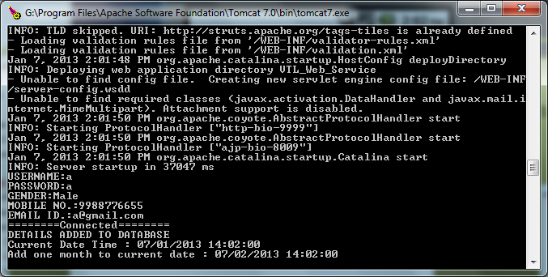

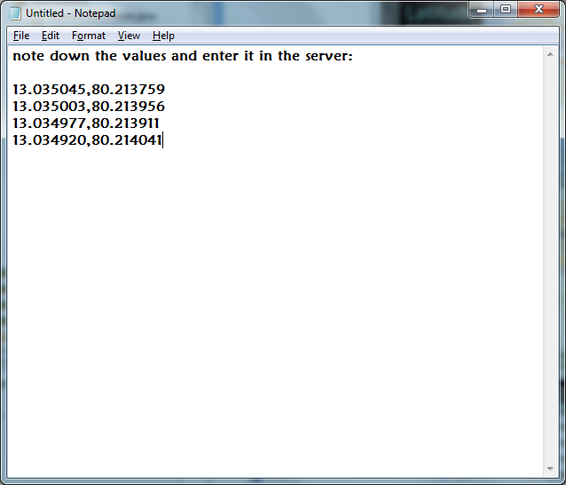

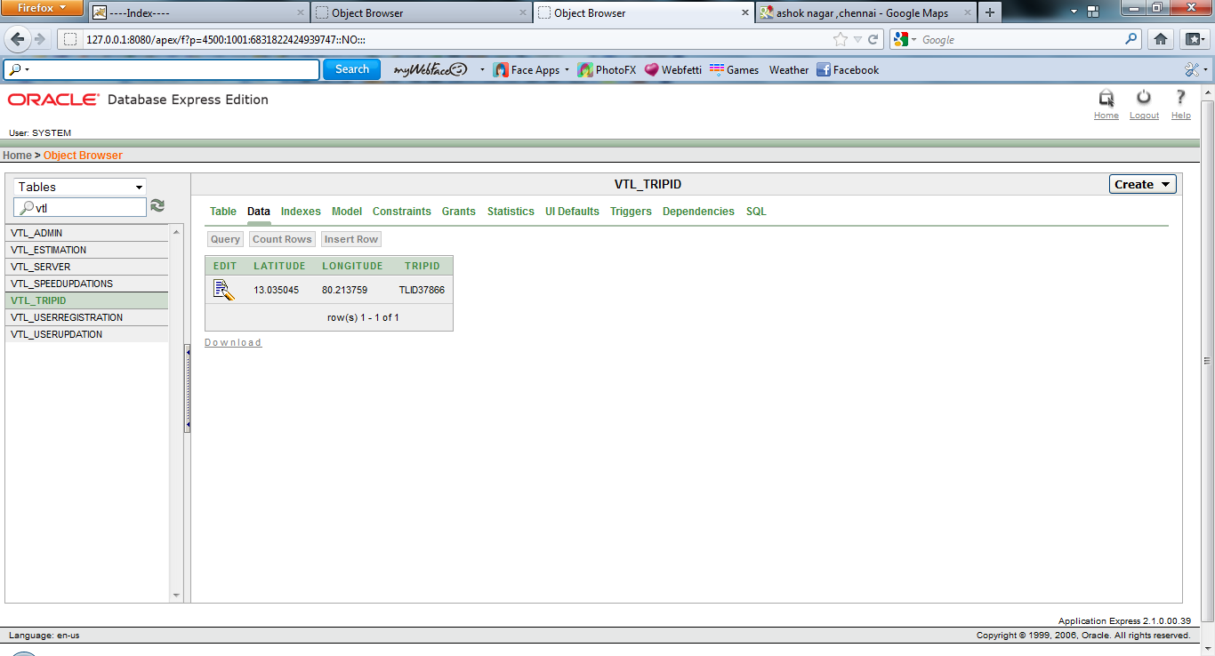

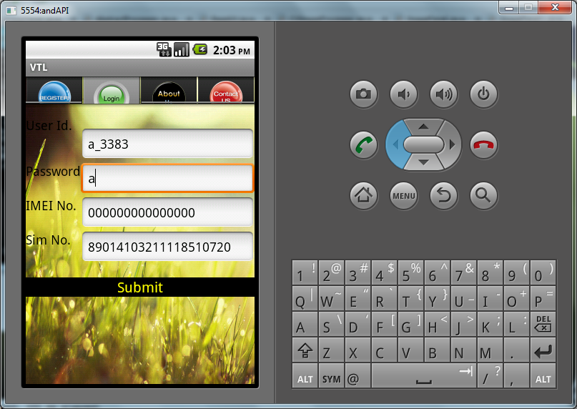
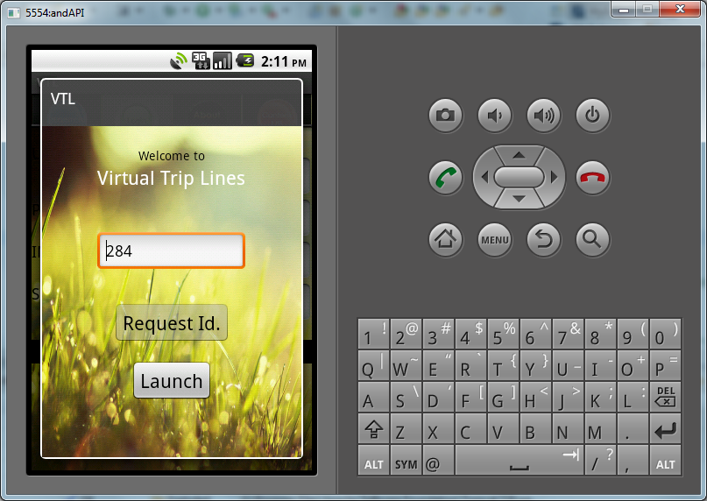

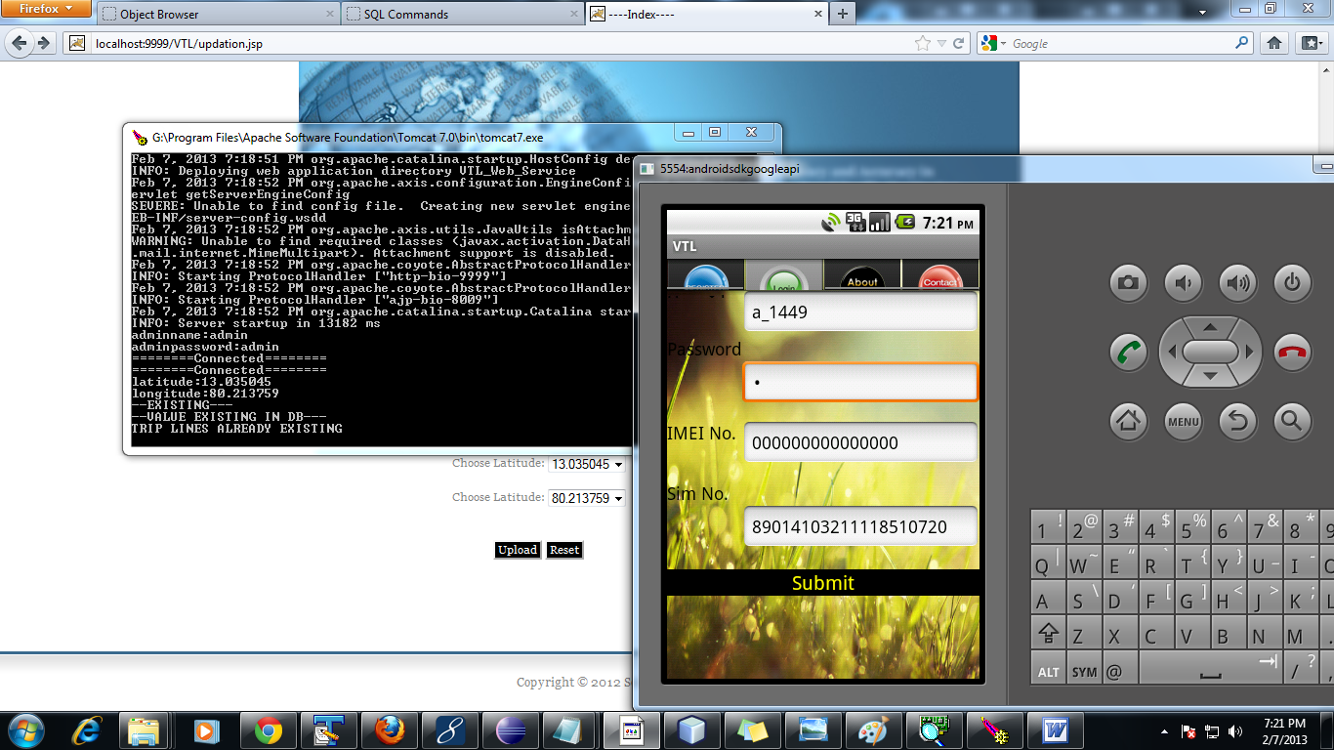

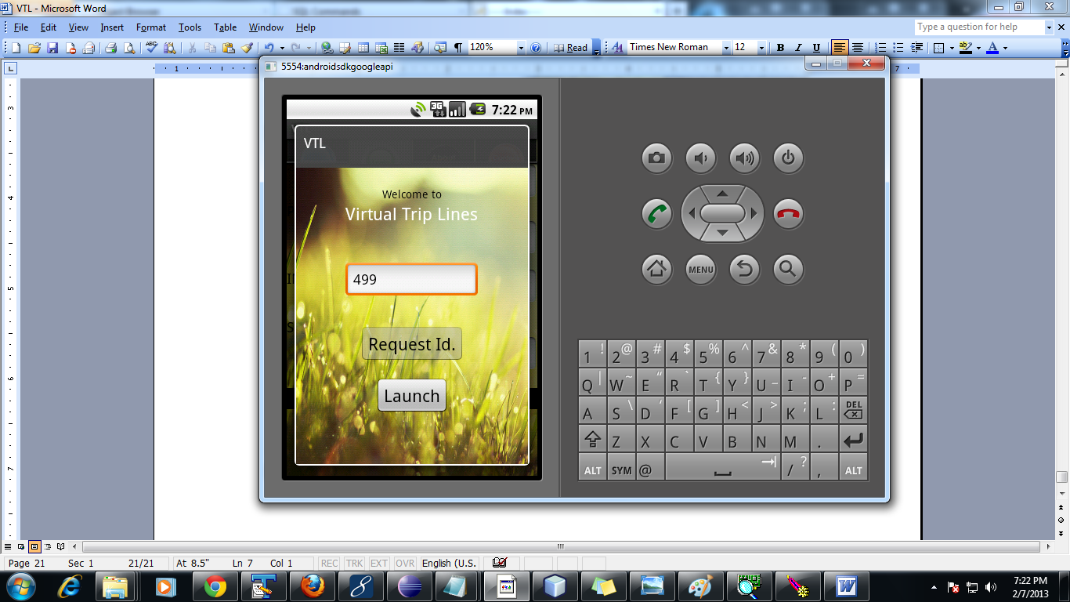

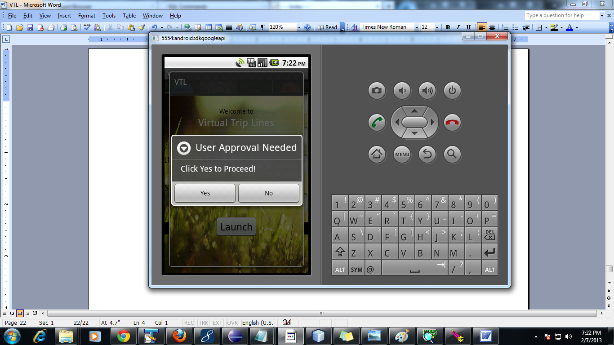
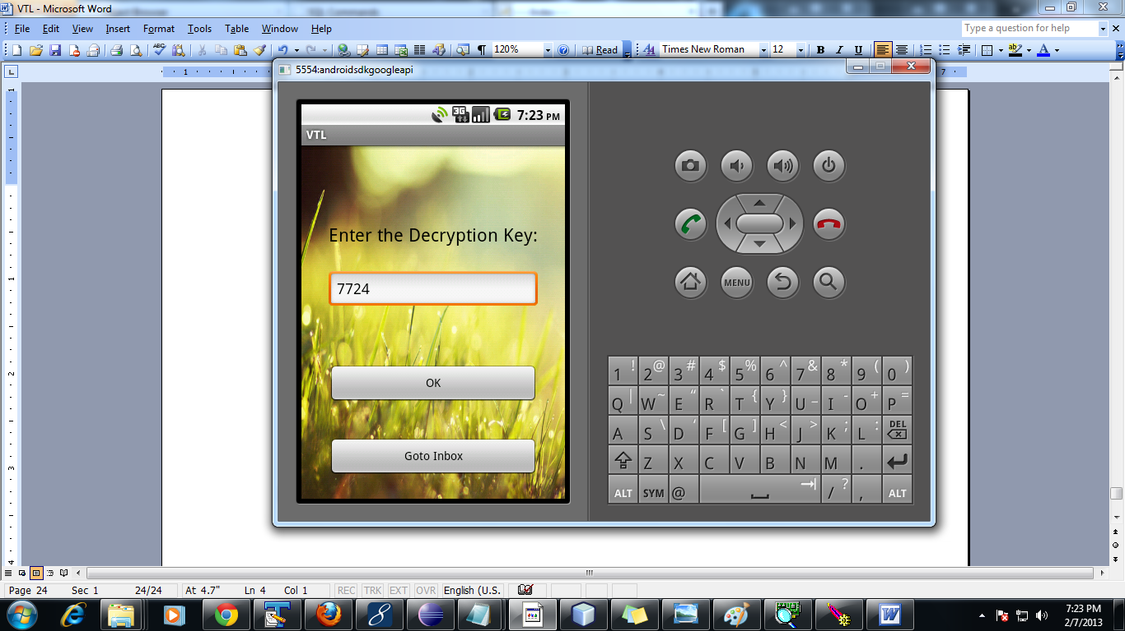

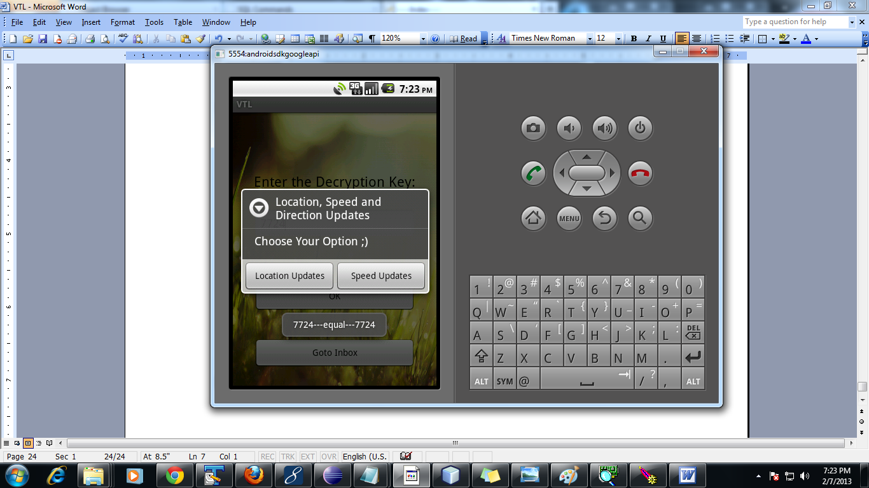

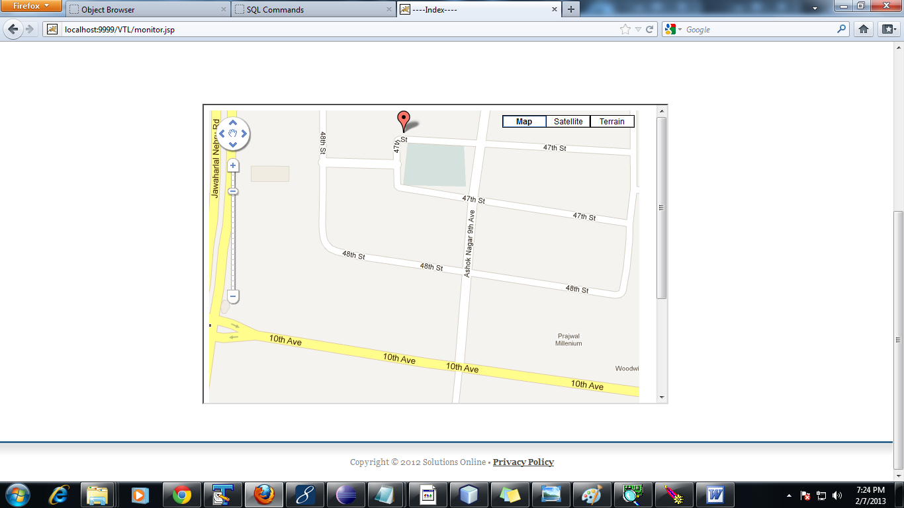

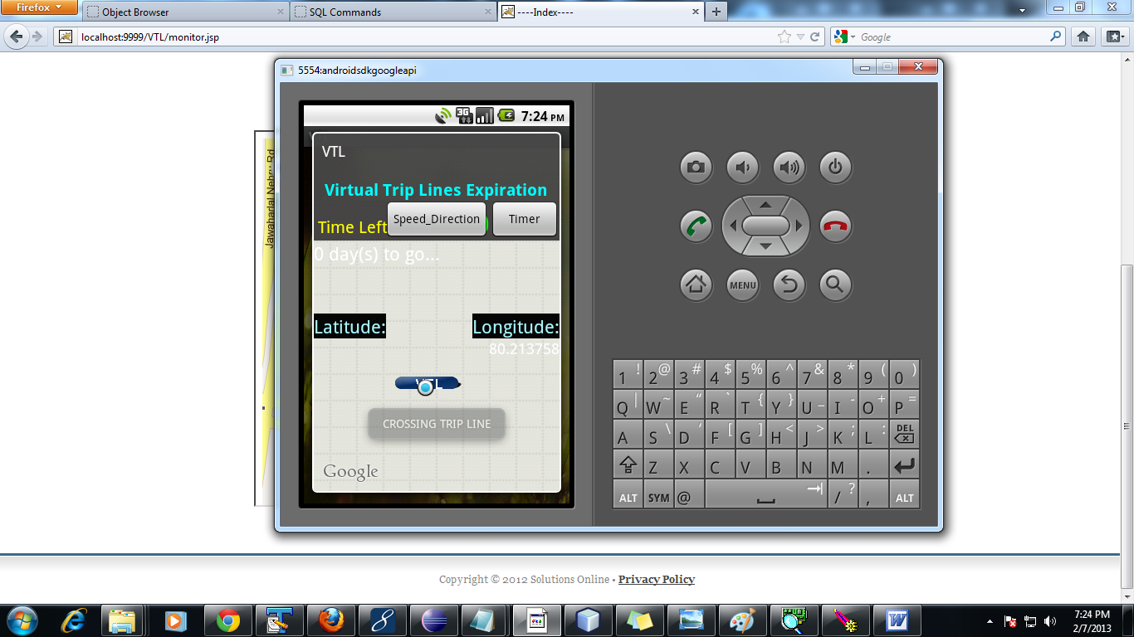

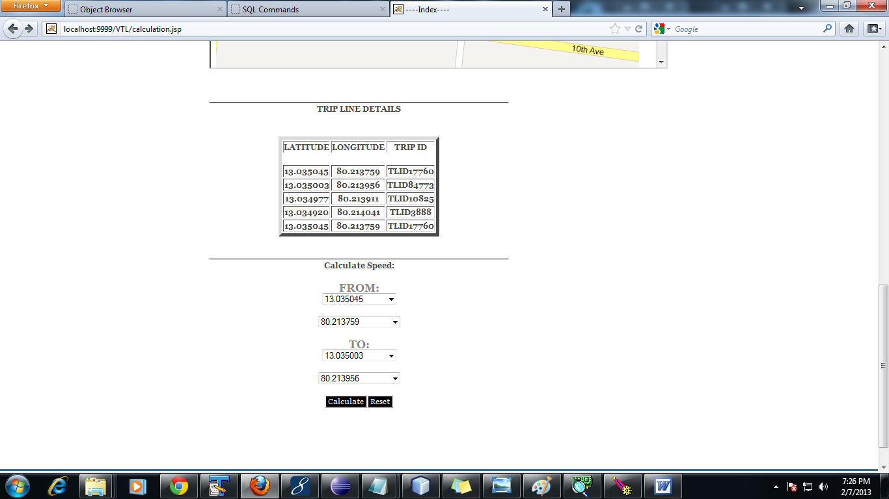

REFERENCES

[1] http://traffic.berkeley.edu, 2011.

[2] http://www.fcc.gov/Bureaus/Wireless, 2011.

[3] http://www.paramics-online.com, 2011.

[4] http://www.privacyrights.org/ar/ChronDataBreaches.htm,2011.

[5] TeleNav, http://www.telenav.net, 2004.

[6] Inrix, http://www.inrix.com, 2006.

[7] Google Maps, http://www.google.com/mobile/maps, 2011.

[8] Waze, http://www.waze.com, 2009.

[9] A. Beresford and F. Stajano, “Mix Zones: User Privacy in Location-Aware Services,” Proc. IEEE Ann. Conf. Pervasive Computing and Comm. Workshop, 2004.

[10] C. Claudel and A.A. Bayen, “Lax-Hopf Based Incorporation of Internal Boundary Conditions into Hamilton-Jacobi Equation. Part II: Computational Methods,” IEEE Trans. Automatic Control, vol. 55, no. 5, pp. 1158-1174, May 2010.

